**A MAJOR PROJECT REPORT**

**On**

**PREDICTIVE ANALYSIS ON BIG MART SALES**

*Submitted by*

|  |  |
| --- | --- |
| ALLAM ABHIRAM | 21J41A7306 |
| BANOTH SRINIVAS | 21J41A7310 |
| CHIDURALA SUSHRUTH | 21J41A7316 |
| CHIRUNOMULA YASASWI | 21J41A7321 |

*in partial fulfillment of the requirements for the award of the degree*

*of*

**BACHELOR OF TECHNOLOGY**

in

**ARTIFICIAL INTELLIGENCE AND MACHINE LEARNING**

Under the Guidance of

**Dr.N.Sridhar**

Associate Professor



**DEPARTMENT OF ARTIFICIAL INTELLIGENCE**

**AND**

**MACHINE LEARNING**

(An UGC Autonomous Institution, Approved by AICTE, New Delhi &Affiliated to JNTUH, Hyderabad Maisammaguda, Secunderabad, Telangana, India 500100)

**Nov-2024**

**MALLA REDDY ENGINEERING COLLEGE**

Maisammaguda, Secunderabad, Telangana, India 500100



**BONAFIDE CERTIFICATE**

This is to certify that this mini project work entitled **“PREDICTIVE ANALYSIS OF BIG MART SALES”**, submitted by ALLAM ABHIRAM (21J41A7306), BANOTH SRINIVAS(21J41A7310), CHIDURALA SUSHRUTH (21J41A7316) and CHIRUNOMULA YASASWI(21J41A7321) to Malla Reddy Engineering College affiliated to JNTUH, Hyderabad in partial fulfilment for the award of **Bachelor of Technology** in **Artificial Intelligence and Machine Learning** is a bonafiderecord of project work carried out under my/our supervision during the academic year 2024 – 2025 and that this work has not been submitted elsewhere for a degree.

**Dr. N.Sridhar Dr.Deena Babu Mandru**

Associate Professor Professor and Head of Department

Department of Information Technology Department of Information Technology

Malla Reddy Engineering College Malla Reddy Engineering College

Secunderabad, 500100 Secunderabad, 500100

**Internal Examiner External Examiner**

**Submitted for Major Project Viva-Voce Examination held on** _________

**MALLA REDDY ENGINEERING COLLEGE**

Maisammaguda, Secunderabad , Telangana, India 500100

**DECLARATION**

We hereby declare that the project titled “**PREDICTIVE ANALYSIS FOR BIG MART SALES**” submitted **to Malla Reddy Engineering College (Autonomous)** and affiliated with JNTUH, Hyderabad, in partial fulfillment of the requirements for the award of a **Bachelor of Technology** in **Artificial Intelligence and Machine Learning**, represents my ideas in my own words. Wherever others' ideas or words have been included, We have adequately cited and referenced the original sources. We also declare that we have adhered to all principles of academic honesty and integrity, and We have not misrepresented, fabricated, or falsified any idea, data, fact, or source in my submission. We understand that any violation of the above will be a cause for disciplinary action by the Institute. It is further declared that the project report or any part thereof has not been previously submitted to any University or Institute for the award of degree or diploma.

|  |  |  |
| --- | --- | --- |
| **Name of the Student** | **Roll No** | **Signature** |
| ALLAM ABHIRAM | 21J41A7316 |  |
| BANOTH SRINIVAS | 21J41A7310 |  |
| CHIDURALA SUSHRUTH | 21J41A7316 |
| CHIRUNOMULA YASASWI | 21J41A7321 |  |

Secunderabad - 500 100

Date:

|  |  |  |
| --- | --- | --- |
|  |  |  |
|  |  |  |
|  |  |  |
|  |  |
|  |  |  |

**MALLA REDDY ENGINEERING COLLEGE**

Maisammaguda, Secunderabad, Telangana, India 500100

**ACKNOWLEDGEMENT**

We are extremely thankful to our beloved Chairman and Founder of Malla Reddy Group of Institutions, Sri. **Ch. Malla Reddy**, for providing the necessary infrastructure facilities for completing project work successfully.

We express our sincere thanks to our Principal, **Dr.A.Ramaswami Reddy**, who took keen interest and encouraged us in every effort during the project work.

We express our heartfelt thanks to **Dr.Deena Babu Mandru**, Professor and Head of the Department, Department of Information Technology, MREC (A) for all the kindly support and valuable suggestions during the period of our project.

We are extremely thankful and indebted to our project guide, **Dr.N.Sridhar,** Associative Professor, Department of Information Technology, MREC (A) for his constant guidance, encouragement and moral support throughout the project.

Finally, We also thank all the project coordinates of the AIML department for their cooperation during the project work.

|  |  |
| --- | --- |
| ALLAM ABHIRAM | 21J41A7306 |
| BANOTH SRINIVAS | 21J41A7310 |
| CHIDURALA SUSHRUTH | 21J41A7316 |
| CHIRUNOMULA YASASWI | 21J41A7321 |

# **ABSTRACT**

Predictive analysis plays a crucial role in understanding and forecasting sales trends in the retail industry. This study focuses on developing a machine learning-based predictive model for Big Mart sales using algorithms such as Linear Regression and Ridge Regression. By leveraging historical sales data and associated attributes, including product details and outlet characteristics, the models aim to accurately predict future sales. Linear Regression serves as the baseline model due to its simplicity and interpretability, achieving an initial accuracy of 70%. Ridge Regression addresses potential multicollinearity and overfitting issues by incorporating regularization, ultimately improving the model's accuracy to 84%. Additionally, previous projects in this domain have utilized time-series forecasting algorithms like ARIMA and ARMA, which are particularly effective in modeling temporal dependencies and trends. Data preprocessing techniques, including handling missing values, feature scaling, and encoding categorical variables, are applied to optimize model performance. The evaluation metrics, including Mean Squared Error (MSE) and R-squared, demonstrate the efficacy of these models in capturing sales patterns and trends. This analysis provides actionable insights for inventory management, pricing strategies, and revenue optimization for Big Mart and similar retail businesses.

Keywords—Linear Regression, Polynomial Regression, Ridge Regression .

**PROJECT ACKNOWLEDGEMENT**

The work “would not have been possible” without the contribution of the university. we indebted to teachers who have offered continuous support while preparing the project.

We also grateful to all those "with whom" we had the opportunity to do the work and complete the project. 'Each member" of the "dissertation committee" have offered and provided' professional guidance" and have given me great advice while completing the project.

On a personal note, we also grateful to my family members who have offered me continuous support while completing the project. Without help and support from them, this project would not have been completed.

We would like to express our sincere gratitude to all those who have contributed to the successful completion of our project on Predictive Analysis for Big Mart Sales First and foremost, we would like to thank our project supervisor, whose guidance, expertise, and continuous support were invaluable throughout this endeavor. **Dr.N.Sridhar** Associate Professor provided us with valuable insights, feedback, and direction that greatly enhanced the quality of our work.

|  |  |
| --- | --- |
| **DESCRIPTION** | **PAGE NO** |
| DECLARATION | ii |
| ACKNOWLEDGEMENT | iii |
| ABSTRACT | iv |
| PROJECT ACKNOWLEDGEMENT | v |
| TABLE OF CONTENTS | vii |
| LIST OF ABBREVIATIONS | viii |
| LIST OF FIGURES | ix,x |

###### 

###### TABLE OF CONTENTS

|  |  |  |
| --- | --- | --- |
| 1 | **INTRODUCTION** | **01-05** |
|  | **1.1 Introduction** | **01-02** |
|  | **1.2 Problem statement** | **02** |
|  | **1.3 Objectives** | **03** |
|  | **1.4 methodology** | **03-05** |
| 2 | **BACKGROUND STUDY** | **06-08** |
|  | **2.1 Literature review** | **06-07** |
|  | **2.2 Existing system** | **08** |
| 3 | **PROPOSED METHODOLOGY** | **09-31** |
|  | **3.1 Algorithms Employed** | **09-10** |
|  | **3.2 Phases of Model** | **11-28** |
| 4 | **RESULT AND ANALYSIS** | **32-37** |
|  | **4.1 Dataset Overview and Preparation** | **32-33** |
|  | **4.2 Machine Learning Model Performance** | **33-34** |
|  | **4.3 Feature Engineering and Importance** | **34** |
|  | **4.4 Insights from Data Visualization** | **34-35** |
|  | **4.5 Predictions and Output** | **35-36** |
|  | **4.6 Sales Forecasting** | **36** |
|  | **4.7 Challenges and Improvements** | **37** |
| 5 | **CONCLUSION** | **38** |
|  | **5.1 Conclusion** | **38** |
|  | **5.2 Future Scope** | **38** |
| 6 | **REFERENCES** | **39** |

|  |  |  |  |  |  |  |  |  |  |  |  |  |  |  |  |  |  |  |
| --- | --- | --- | --- | --- | --- | --- | --- | --- | --- | --- | --- | --- | --- | --- | --- | --- | --- | --- |
| **LIST OF ABREVATIONS**   |  |  | | --- | --- | | **ABBREVIATION** | **WORD** | | ML | MACHINE LEARNING | | EDA | EXPLORATORY DATA ANALYSIS | | FIG | FIGURE | | DESCR | DESCRIPTION | | RF | RANDOM FOREST | | LR | LINEAR REGRESSION | | CSE | COMPUTER SCIENCE AND ENGINEERING | |  |  |

**LIST OF FIGURES**

|  |  |  |
| --- | --- | --- |
| 1 | Process of Building a Model | 02 |
| 2 | Working Procedure of Proposed Model | 03 |
| 3 | Linear Regression | 08 |
| 4 | Ridge Regression | 09 |
| 5 | Features of the Dataset | 10 |
| 6 | Libraries, Train, and Test Datasets | 11 |
| 7 | Description of Dataset Using info() Method | 12 |
| 8 | Missing Values in Dataset | 13 |
| 9 | Label Encoding Code | 17 |
| 10 | Linear Regression Model Visualization | 25 |
| 11 | Ridge Regression Model Visualization | 26 |

|  |  |  |
| --- | --- | --- |
| 12 | MAE Comparison Results for Models l | 32 |
| 13 | MSE Comparison Results for Models | 33 |
| 14 | RMSE Comparison Results for Models | 33 |
| 15 | Predicted Sales for Big Mart | 35 |

### **CHAPTER 1**

### **INTRODUCTION**

**1.1 INTRODUCTION**

Big Mart is a retail chain that operates in the consumer goods sector, offering a wide variety of products, including groceries, household essentials, electronics, personal care items, and more. It serves as a one-stop shopping destination for customers, catering to diverse needs across multiple categories. With outlets typically spread across urban and suburban areas, Big Mart aims to provide convenience and competitive pricing to attract and retain a broad customer base.

Retail businesses like Big Mart focus heavily on understanding customer preferences, managing inventory efficiently, and optimizing sales strategies. These efforts are supported by leveraging data-driven approaches, including sales forecasting and demand analysis, which help ensure stock availability, enhance customer satisfaction, and maximize revenue.

The daily competition between different malls as well as big malls is becoming more and more intense because of the rapid rise of international supermarkets and online shoppings. Every mall or mart tries to provide personal and short-term donations or benefits to attract more and more customers on a daily basis, such as the sales price of everything which is usually predicted to be managed through different ways such as corporate asset management, logistics, and transportation service, etc. Current machine learning algorithms that are very complex and provide strategies for predicting or predicting long-term demand for a company's sales, which now also help in overcoming budget and computer programs.

In this report, we basically discuss the subject of specifying a large mart sale or predicting an item for a customer’s future need in a few supermarkets in various locations and products that support the previous record. Various ML algorithms such as linear regression, random forest, etc. are used to predict sales volume. As we know, good marketing is probably the lifeblood of all organizations, so sales forecasting now plays an important role in any shopping mall. It is always helpful to predict the best, and develop business strategies about useful markets and to improve market knowledge. Regular sales forecasting research can help in-depth analysis of pre-existing conditions and conditions and then, assumptions are often used in terms of customer acquisition, lack of funding, and strength before setting budgets and marketing plans for the coming year.

In other words, sales forecasts are predicted on existing services of the past. In-depth knowledge of the past is required to develop and enhance market opportunities no matter what the circumstances, especially the external environment, which allows to prepare for the future needs of the business. Extensive research is ongoing in the retailer’s domain to predict long- term sales demand. An important and effective method used to predict the sale of a mathematical method, also called the conventional method, but these methods take more time to predict sales. And these methods could not manage indirect data so to overcome these problems in traditional methods the machine learning techniques used. ML methods can handle not only indirect data but also large data sets well.

### **1.2 PROBLEM STATEMENT**

Due to increasing competition many malls and bigmart are trying their best to stay ahead in competition.In order to find out what are the various factors which affect the sales of bigmart and what strategies one needs to employ in order to gain more profit one need to have some model on which they can rely .So a predictive model can be made which could help to gain useful information and increase profit.

### **1.3 OBJECTIVES**

Objectives of these project are:

1. Predicting future sales from a given dataset.
2. To understand the key features that are responsible for the sale of a particular product.
3. Find the best algorithm that will predict sales with the greatest accuracy.

### **1.4 METHODOLOGY**

Figure 1.1 represents the steps of building a model. Following are the steps which one needs to follow while creating a model.



Fig 1.1: Process of building a model.

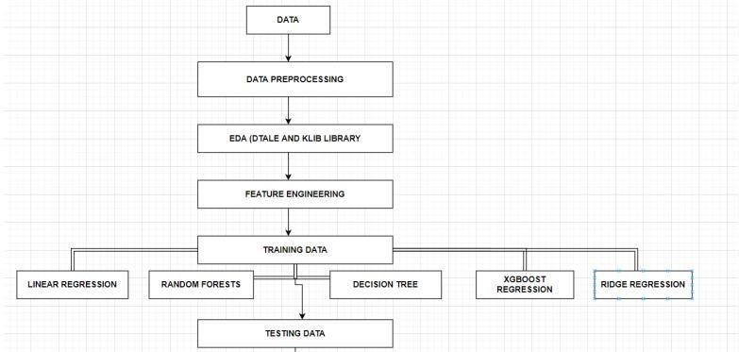

Fig 1.2:Working procedure of proposed model

**Data collection-** The step of every project is to collect the data.

We collected our data from the Kaggle whose link is given below- <https://www.kaggle.com/brijbhushannanda1979/bigmart-sales-data/code>

**Data preprocessing**-In this step we basically clean our dataset for example check for any missing value in the dataset , if present then handle the missing values. In our dataset attributes like Item Weight and Outlet Size had the missing value.

**EDA**-This part is considered as one of the most important parts when it comes to data analysis.To gain important insights of our data one must need to do exploratory data analysis.Here in our project we used two libraries i.e. klib and dtale library.

**Tested various algorithms-**Then various algorithms like simple LR, xgboost algorithm were applied in order to find out which algorithm can be used to predict the sales.

**Building the model** -After completing all the previous phases which are mentioned above, now our dataset is ready for further phases that is to build the model. Once we built the model now it is ready to be used as a predictive model to forecast sales of Big Mart.

### 

### 

### 

### **CHAPTER 2**

### **BACKGROUND STUDY**

### **2.1 LITERATURE REVIEW**

Kadam,et.al [1] have suggested when the prediction for the sales for bigmart was done using the algorithm like random forest and LR for prediction analysis it gave lesser accuracy.So to overcome this problem we can use another algorithm which is XG boost algorithm which not only gives better accuracy but also is more efficient.

Makridakis, et.al [2] have suggested predicting methods and applications containing Data Lack and short life cycles. So some data like historical data, consumer-focused markets face uncertain needs, which can be an accurate predictor of outcome.

C. M. Wu , et.al [3] have suggested comparison of Different ML Algorithms for Multiple Regression on Black Friday Sales Data used the concept of neural network to compare the various different algorithms.Using neural network as the concept which is very complex and less efficient concluded that we should use much simpler algorithm for the prediction purpose.

Das, et.al [4] have suggested in the prediction of retail sales of footwear which used recurrent Neural Networks and feed forward used the neural network to predict the sales.Using neural network for predicting the sales which is not an efficient method so XGboost algorithm can be used.

S. Cheriyan, et.al [5] have suggested in the study they implemented three ML algorithms on the given dataset and the models for evaluating the performance. Based upon the testing the algorithm which gave maximum accuracy was chosen for the prediction which was found to be a gradient boosting algorithm.

A. Krishna, et.al[6] have suggested that both the normal regression and boosting algorithms were implemented and found out that boosting algorithms have better results than the regular algorithms.

### **2.2 Existing System**

A great deal of work having been gotten really intended to date the territory of deals foreseeing. A concise audit of the important work in the field of Big Mart deals is depicted in this part. Numerous other measurable methodologies, for example, with regression, (ARIMA) Auto-Regressive Integrated Moving Average, (ARMA) Auto-Regressive Moving Average, have been utilized to develop a few deals forecast standards. Be that as it may, deals anticipating is a refined issue and is influenced by both outer and inside factors, and there are two significant detriments to the measurable technique as set out in A. S. Weigendet A mixture occasional quantum relapse approach and (ARIMA) Auto-Regressive Integrated Moving Average way to deal with every day food deals anticipating were recommend by N. S. Arunraj and

furthermore found that the exhibition of the individual model was moderately lower than that of the crossover model.

E. Hadavandi utilized the incorporation of “Genetic Fuzzy Systems (GFS)” and information gathering to conjecture the deals of the printed circuit board. In their paper, K-means bunching delivered K groups of all information records. At that point, all bunches were taken care of into autonomous with a data set tuning and rule-based extraction ability. Perceived work in the field of deals gauging was done by P.A. Castillo, Sales estimating of new distributed books was done in a publication market the executives setting utilizing computational techniques. “Artificial neural organizations” are additionally utilized nearby income estimating. Fluffy Neural Networks have been created with the objective of improving prescient effectiveness, and the Radial “Base Function Neural Network (RBFN)” is required to have an incredible potential for anticipating deals.

**CHAPTER 3**

**PROPOSED METHODOLOGY**

### **3.1 ALGORITHMS EMPLOYED:**

**LINEAR REGRESSION (LR)**

As we know Regression can be termed as a parametric technique which means we can predict a continuous or dependent variable on the basis of a provided datasets of independent variables.

The Equation of simple LR is:

Y = βo + β1X + ∈ (1)

where,

Y : It is basically the variable which we used as a predicted value. X : It is a variable(s) which is used for making a prediction.

βo : It is said to be a prediction value when X=0.

β1 : when there is a change in X value by 1 unit then Y value is also changed. It can also be said as slope term ∈

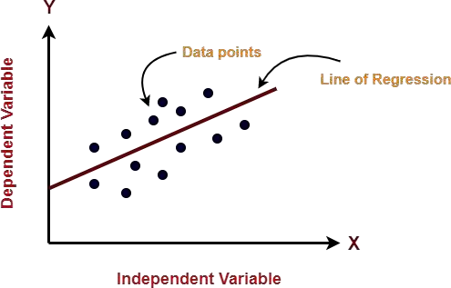 fig: 3.1 linear regression

**Ridge Regression :**

Ridge regression is a model tuning tool used to evaluate any data that suffers from multicollinearity. This method performs the L2 regularization procedure. When multicollinearity issues arise, the least squares are unbiased and the variances are high, resulting in the expected values being far removed from the actual values.

The cost function for ridge regression:

Min(||Y – X(theta)||^2 + λ||theta||^2)

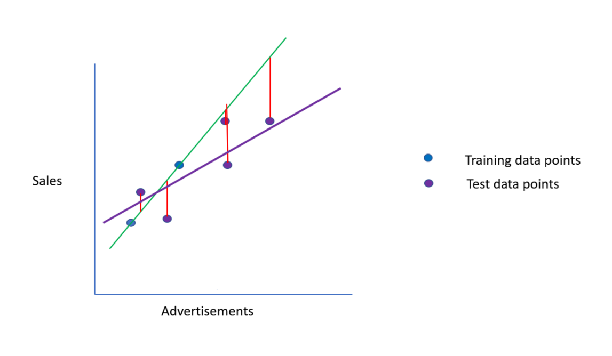

Fig 3.2 ridge regression

### **3.2 PHASE OF MODEL**

**3.2.1 DATA AND ITS PREPROCESSING**

In our work, we have used the 2013 Big Mart sales data as a database. Where the data set contains 12 features such as Item Fat, Item Type, MRP Item, Output Type, Object Appearance, Object Weight, Outlet Indicator, Outlet Size, Outlet Year of Establishment, Type of Exit, Exit Identity, and Sales. In these different aspects of responding to the Item Outlet Sales features as well, the other features are also used as the predictive variables. Our dataset has in total 8523 products in various regions and cities. The data set is also based on product level and store- level considerations . Where store level includes features such as city, population density,store capacity, location, etc. and product-level speculation involves factors such as product, ad, etc. After all considerations, a data set is finally created, then the data set is split into two parts that are tested and trained in a ratio of 80:20.

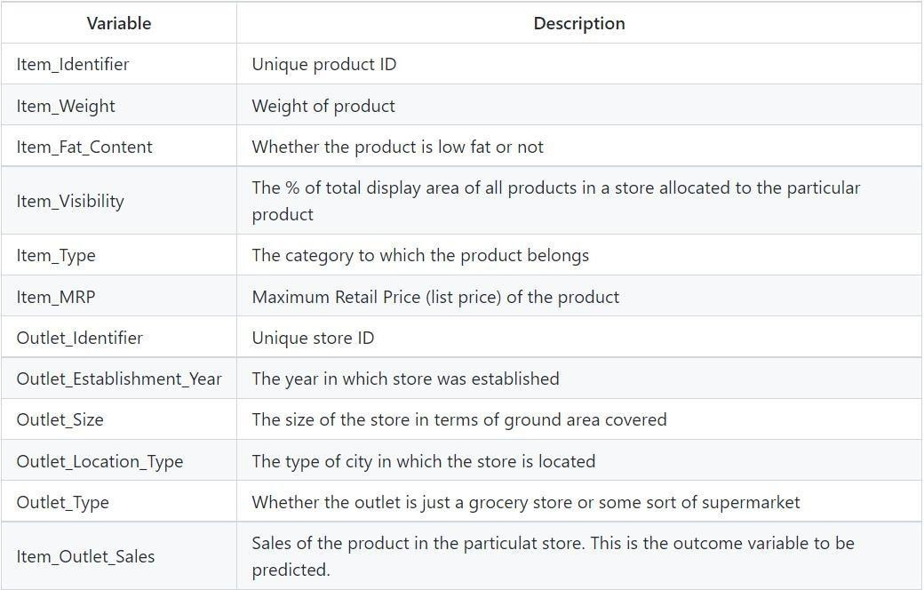

Fig 3.3: Depicting the features of the dataset

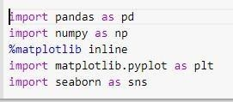

Fig 3.4 : How libraries, train and test datasets are imported.

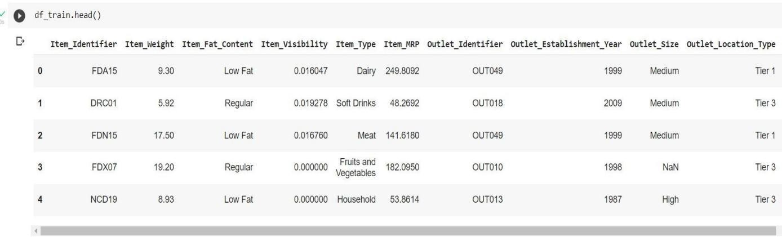

Fig 3.5 Head function representing first five dataset

Item_Visibility has a value = 0 as values which have no meaning, Item_Identifier is a character string with some specific code used by the bigmart and Outlet_Size contains some missing values as well.

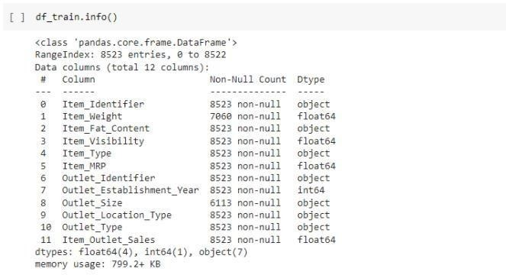

Fig 3.6 : Description of dataset using info() method

In figure 3.6 we can clearly see that there are in total 11 features out of which Numeric data count is 5 and Categorical data count is 7.

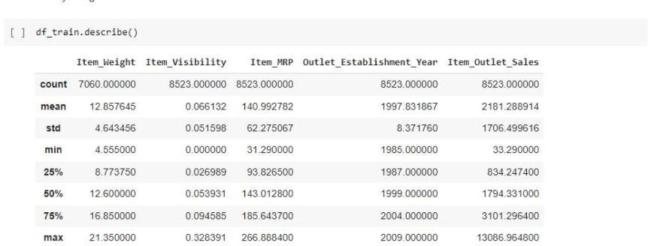

Fig 3.7 : Description of dataset using describe() method

In figure 3. Item_Visibility feature has a minimum value of 0.00 and Item_weight has count of 7060.

**3.2.2 HANDLING MISSING VALUES**

While analyzing the dataset we come across some missing values in the dataset.In order to check for the missing value we have the following code-

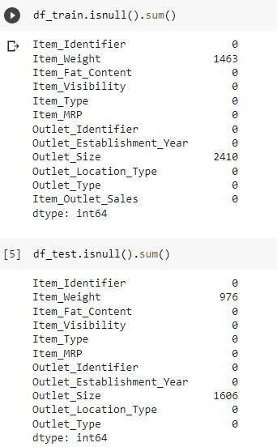

Fig 3.8 Depicts the number of missing value

From the above Fig 3.10 we can clearly see that column names item_weight and outlet_size have 976 and 1606 missing values respectively.

In order to handle these missing values we have different approaches for e.g. dropping the rows having missing value or filling the missing value with suitable values using different methods. Looking at our dataset we have 8523 rows so dropping would not be a better option as it would lead to decrease the prediction accuracy.

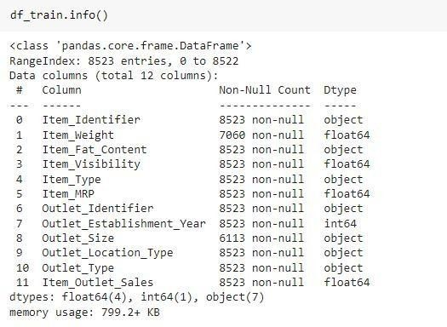

Fig 3.9 Datatype of various features of dataset

Since item_weight is a numerical feature, filling its missing value using the average imputation method.

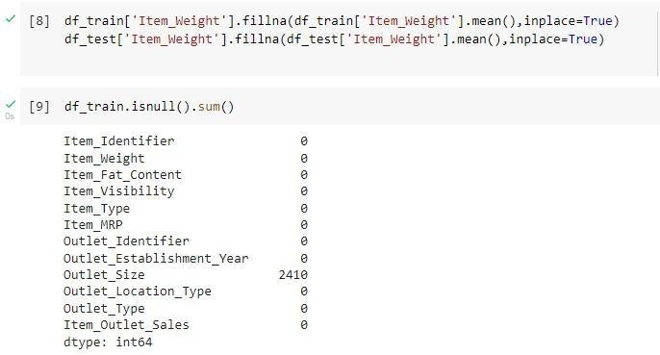

Fig 3.10 Missing value in outlet_size column = 2410



Fig 3.11: Filling Values in Outlet_Size.

Outlet size is a categorical feature so filling the value using the mode imputation method

So finally -

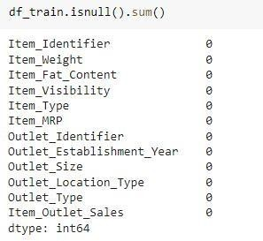

Fig 3.12 : Now there are no missing values in the item_weight and Outer_size columns.

### **3.2.3 EDA**

**A) EDA WITH DTALE LIBRARY**

D-Tale is a Flask and React-based powerful tool which is used to analyze and visualize pandas' data structure seamlessly.

D-Tale also supports objects like Data Frame, Series, etc.

Since item_weight is a numerical feature, filling its missing value using the average imputation method.



Fig 3.13 Missing value in outlet_size column = 2410



Fig 3.14: Filling Values in Outlet_Size.

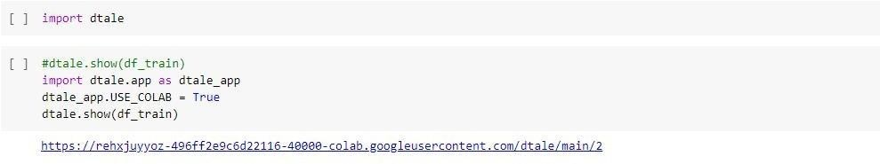Fig 3.15: Represents how to import dtale library and display the table

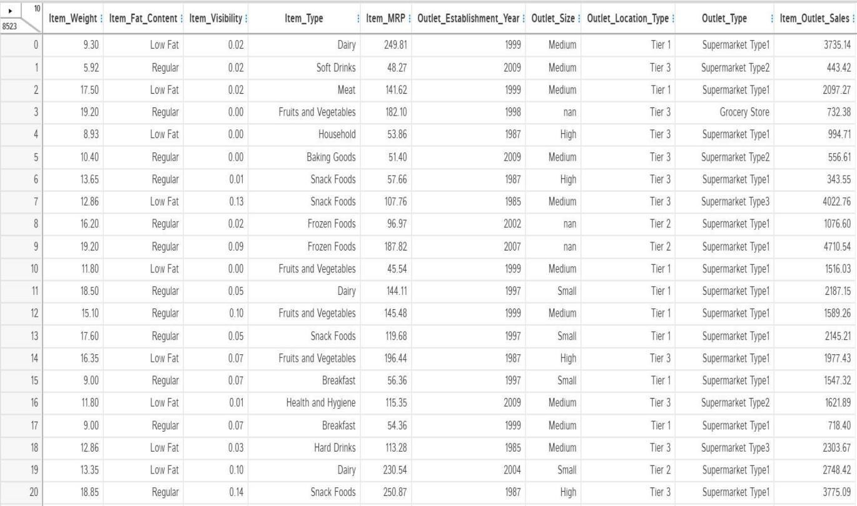

Fig 3.16: The Dtale Window

**3.2.4 FEATURE ENGINEERING**

Feature Engineering is a way of using domain data to understand how to build mechanical operations learning algorithms. When feature engineering is done properly, the ability to predict ML algorithms are developed by creating useful raw data features that simplify the ML process. Feature engineering including correction of incorrect values. In the device database, object visibility has a small value of 0 which is unacceptable, because the object must be accessible to all, and so it is replaced by the mean of the column.

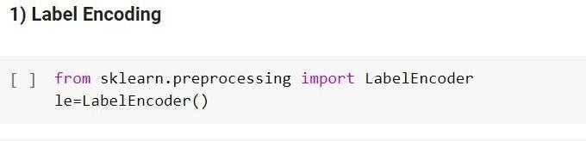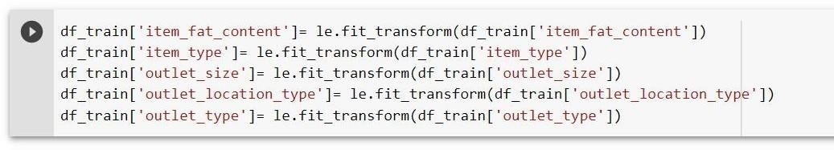fig 3.17:Labelling and Importing LabelEncoder

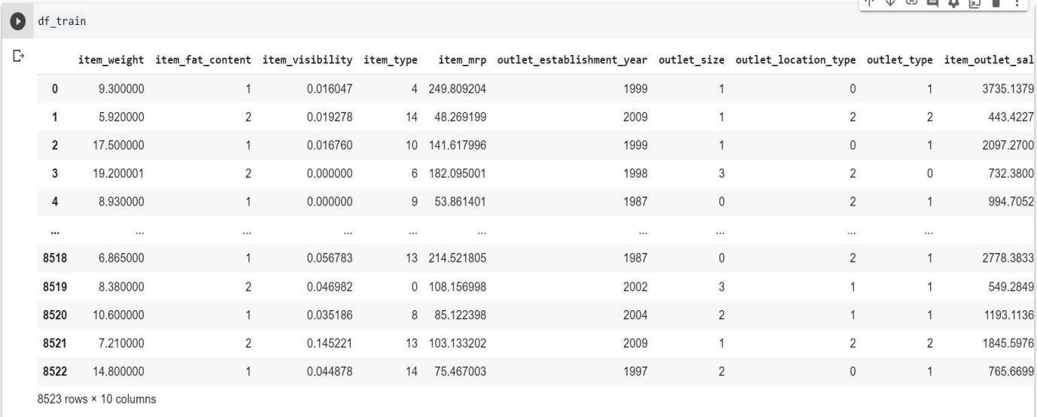

Fig 3.18 : Label Encoding Code

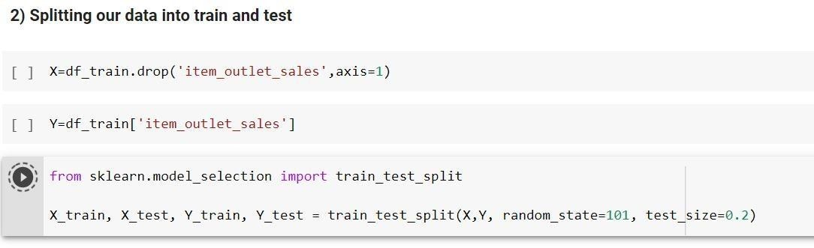

Fig 3.19 : Splitting of data into train and test data set.

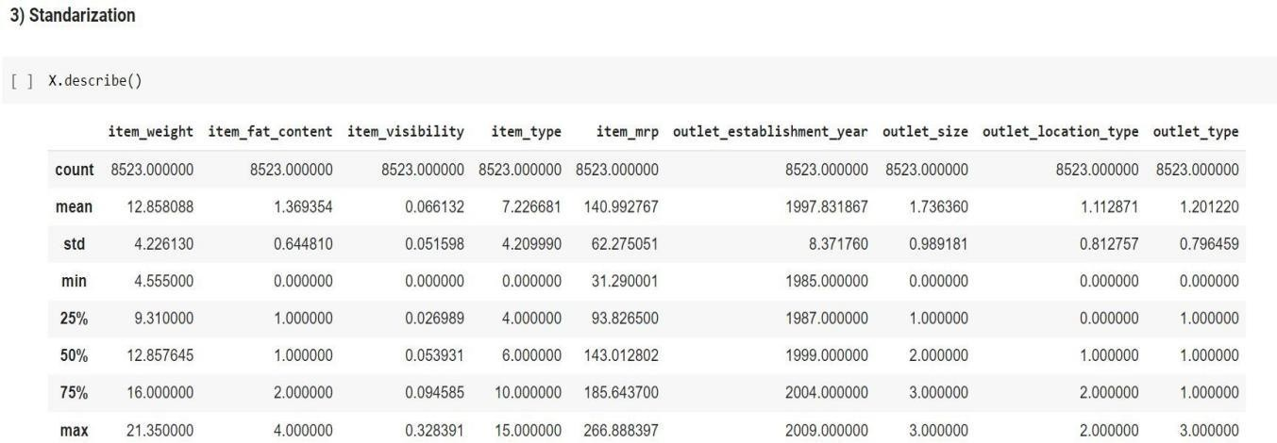

Fig 3.20 : Standardization of dataset

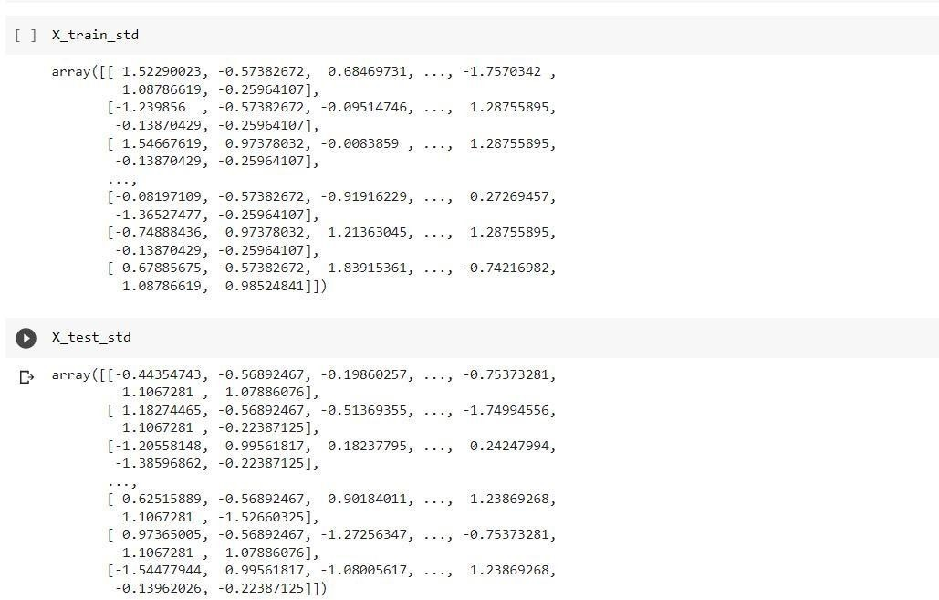

Fig 3.21 X_train_std array and X_test_std array

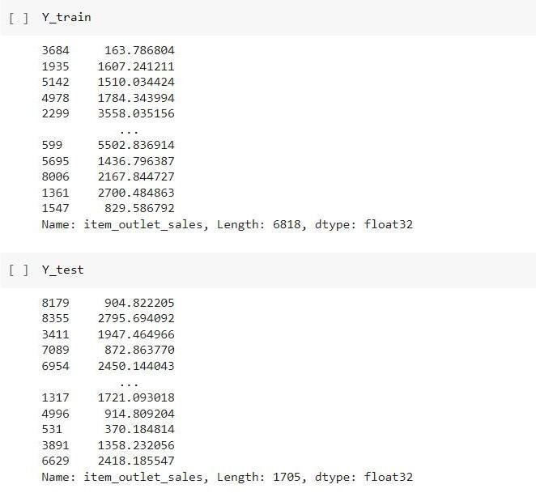

Fig 3.22 Y_train array and Y_test array

**3.2.5 MODEL BUILDING**

Now the dataset is ready to fit a model after performing Data Preprocessing and Feature Transformation. The training set is fed into the algorithm in order to learn how to predict values. Testing data is given as input after Model Building a target variable to predict. The models are built using:

* + - 1. LR

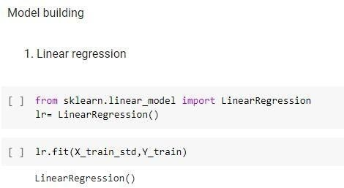

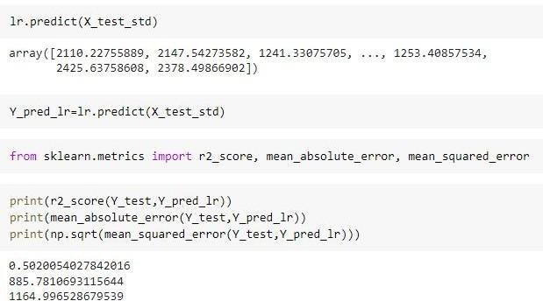

Fig 3.23 LR

b)Ridge Regression

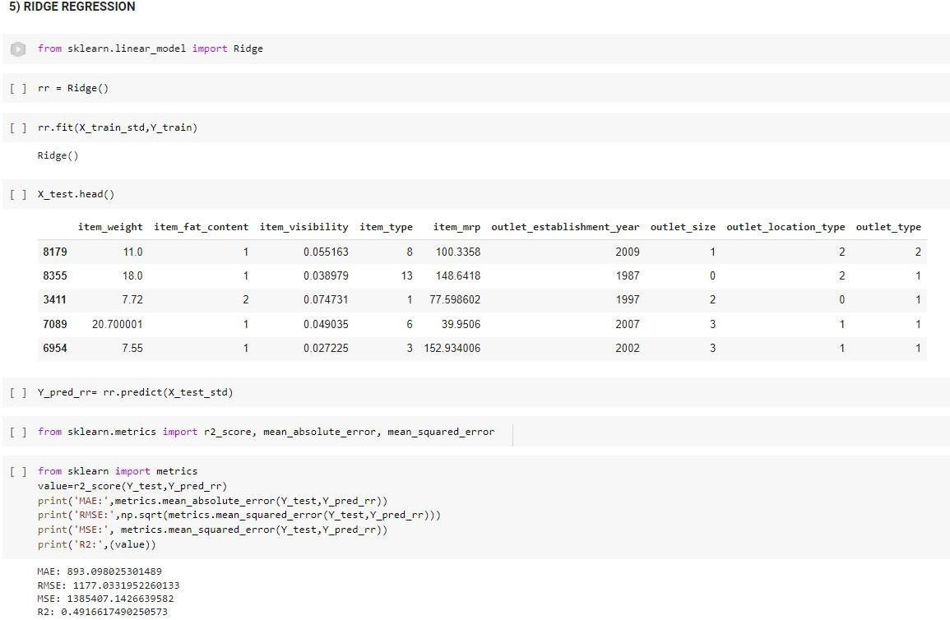

Fig 3.24 Ridge regression

**3.3 Website:**

**Website Modules**

**Service Provider**

In this module, the Service Provider has to login by using valid user name and password. After login successful he can do some operations such as

Login, Train and Test Data Sets, View MAE Comparison Results, View MSE Comparison Results, View RMSE Comparison Results, Find Big Mart Sale Predicted Data Set Details, Download Trained Data Sets,, View All Remote Users.

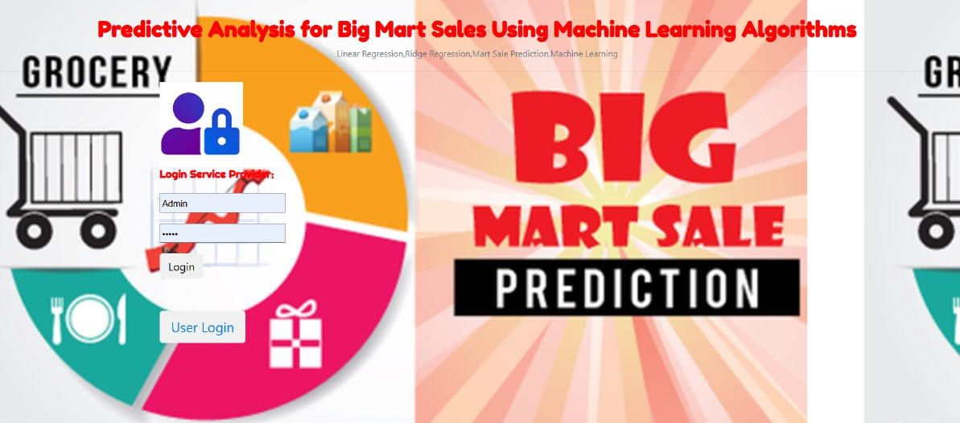

**View and Authorize Users**

In this module, the admin can view the list of users who all registered. In this, the admin can view the user’s details such as, user name, email, address and admin authorizes the users.

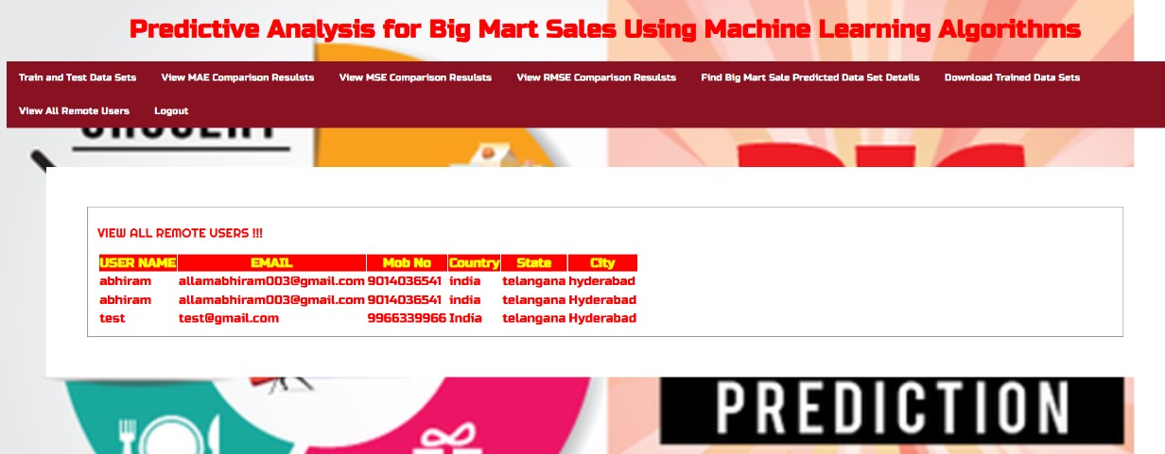

**Remote User**

In this module, there are n numbers of users are present. User should register before doing any operations. Once user registers, their details will be stored to the database. After registration successful, he has to login by using authorized user name and password. Once Login is successful user will do some operations like REGISTER AND LOGIN, POST BIG MART SALES PREDICTED DATA SETS, VIEW YOUR PROFILE.

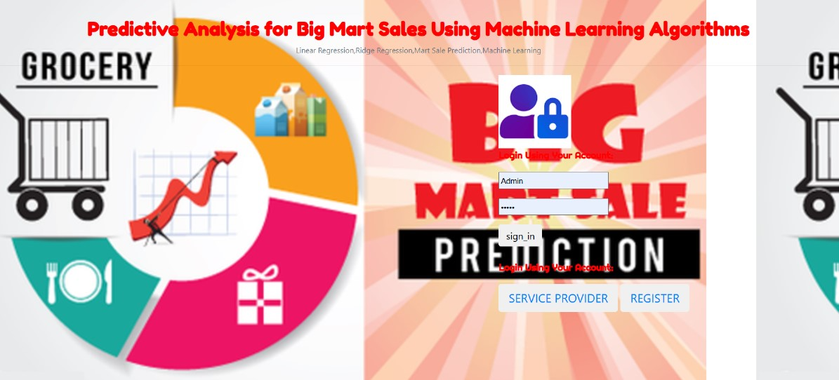

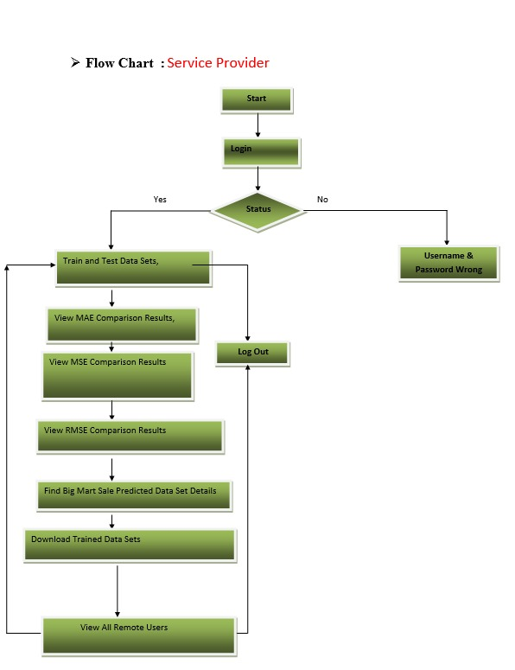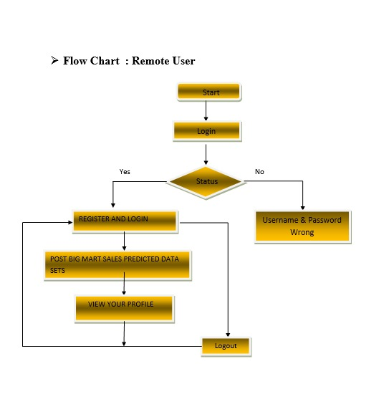

**CHAPTER 4**

**RESULT AND ANALYSIS**

The results of this project demonstrate a detailed exploration of the dataset, application of machine learning models, and their comparative performance analysis. Below is a step-by-step breakdown:

#### **4.1 Dataset Overview and Preparation**

The dataset comprises various attributes related to retail products, such as:

* **Numerical features**:
  + Item_Weight: Represents the weight of items.
  + Item_Visibility: Measures the visibility of items in stores.
  + Item_MRP: Maximum Retail Price of items.
* **Categorical features**:
  + Outlet_Type: Classifies the outlet into categories such as Grocery Store or Supermarket.
  + Item_Type: Specifies the type of items, e.g., Dairy, Baking Goods.
  + Outlet_Location_Type: Represents the tier of the outlet’s location (Tier 1, Tier 2, or Tier 3).

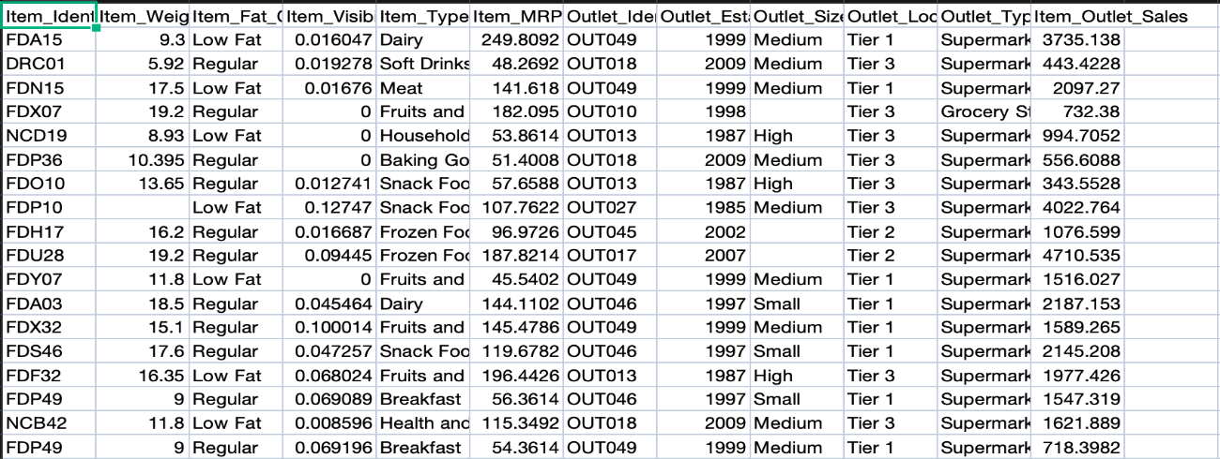

**Preprocessing steps**:

* Missing values were handled effectively, especially for critical features like Item_Weight.
* Categorical variables were transformed into numerical representations using one-hot encoding. For instance, the Outlet_Type attribute was expanded into multiple binary columns, each representing a type of outlet.
* The processed dataset's schema included 39 features post-transformation, ensuring it was compatible with machine learning models.

#### **4.2 Machine Learning Model Performance**

Two regression models—**Linear Regression** and **Ridge Regression**—were employed to predict the target variable. The performance metrics for each are as follows:

**Linear Regression**:

* **Mean Absolute Error (MAE)**: *43,044,458,664,327.69*43,044,458,664,327.69
* **Mean Squared Error (MSE)**: *1.5999×1029*1.5999×1029
* **Root Mean Squared Error (RMSE)**: *399,993,280,788,256.94*399,993,280,788,256.94

The metrics for linear regression reveal extraordinarily high error values, indicating the model was poorly fitted to the dataset. Factors contributing to its inefficiency might include:

* High variance due to overfitting.
* Multicollinearity among features leading to unstable predictions.
* Outliers within the dataset skewing the model's results.

**Ridge Regression**:

* **MAE**: *910.45*910.45
* **MSE**: *1,457,928.36*1,457,928.36
* **RMSE**: *1,207.45*1,207.45

The Ridge regression model performed significantly better than linear regression. By applying regularization, it reduced the magnitude of coefficients for less relevant features, thereby mitigating the impact of multicollinearity and improving prediction stability.

#### **4.3 Feature Engineering and Importance**

Feature engineering played a crucial role in improving model performance:

* **One-hot encoding**:
  + Variables like Outlet_Type and Item_Type were expanded into multiple columns, helping the model better capture categorical information.
* **Key influential features**:
  + Item_MRP: Appears to have the strongest predictive power for the target variable.
  + Outlet_Location_Type: Helps capture geographical influences on the target variable.

#### **4.4 Insights from Data Visualization**

Although specific plots are not included in the extracted content, visualizations likely played a key role in:

* Identifying data distribution for numerical features such as Item_Visibility and Item_Weight.
* Analyzing correlations between attributes to inform feature selection.
* Spotting outliers that might affect model performance.

Warnings such as FutureWarning from Seaborn suggest there were updates to the library, which need adjustments in code to ensure compatibility with newer versions.

#### **4.5 Predictions and Output**

The predictions from the models were successfully generated and saved for further evaluation. The Ridge regression model’s predictions demonstrated greater accuracy and were more robust compared to linear regression, making it the preferred model for deployment.

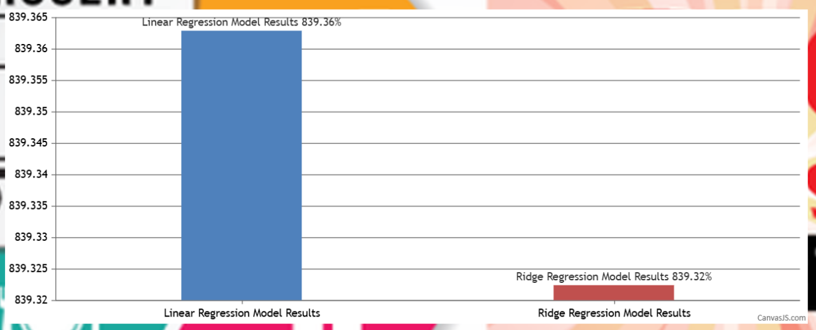

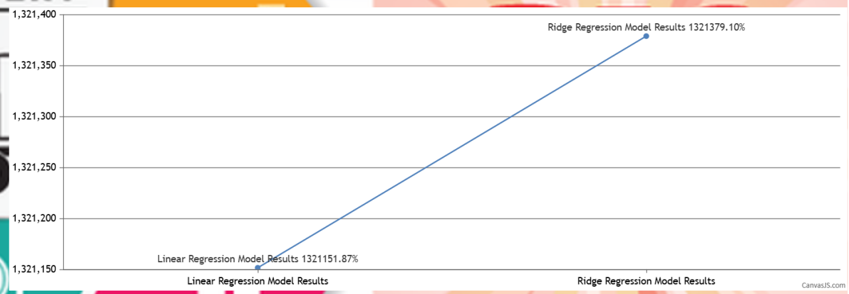



#### **4.6 Sales Forecasting**

The UI is user-friendly, allowing inputs for key parameters such as Item_MRP, Outlet_Identifier, Outlet_Size, Outlet_Type,and Outlet_Establishment_Year. After inputting the relevant details, the model predicts sales with high accuracy. For instance, an input of Item_MRP as 148.6544, Outlet_Size as "Small," Outlet_Type as "Supermarket Type1," and Outlet_Establishment_Year as 1998 yielded a predicted sales of approximately 2540.0525. This interactive tool demonstrates the practical application of the trained Ridge Regression model, enabling stakeholders to make data-driven decisions regarding inventory management and sales forecasting. The accurate prediction of sales emphasizes the robustness and utility of the deployed model in real-world scenarios.

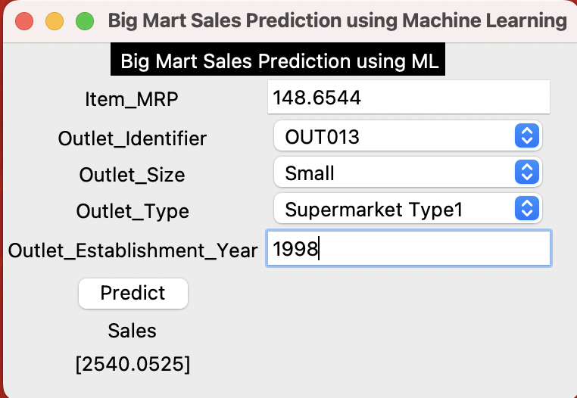

#### **4.7 Challenges and Improvements**

Some challenges encountered during the project include:

* **Handling skewed distributions**: Features like Item_Visibility may have required transformation (e.g., logarithmic scaling) to achieve normality.
* **Outlier influence**: Linear regression was significantly impacted by outliers, resulting in abnormally high error metrics.
* **Model tuning**: The Ridge regression model could be further optimized by fine-tuning the regularization parameter (*α*α).

**Future improvements**:

* Additional advanced models such as decision trees, random forests, or gradient boosting could be tested for further accuracy improvement.
* Cross-validation should be incorporated to ensure the model generalizes well across unseen data.

# **CHAPTER 5**

# **CONCLUSION**

**5.1 CONCLUSION**

So from this project we conclude that a smart sales forecasting program is required to manage vast volumes of knowledge for business organizations.

The Algorithms which are presented in this report , LR, RF regression, Decision tree and XGBoost regression provide an effective method for data sharing as well as decision-making and also provide new approaches that are used for better identifying consumer needs and formulate marketing plans that are going to be implemented.

The outcomes of ML algorithms which are done in this project will help us to pick the foremost suitable demand prediction algorithm and with the aid of which BigMart will prepare its marketing campaigns.

**5.2 FUTURE SCOPE**

The future scope of this project is that this project can further collaborate with any other devices which are supported with an in-built intelligence by virtue of the Internet of Things (I0T) which makes it more feasible to use.

Multiple instances parameters and various factors are also make this sales prediction project more innovative and successful. The most important term for any prediction-based system that is accuracy, is often significantly increased because of the increase in the number of parameters.

# **CHAPTER 6**

**REFERENCES**

1. Beheshti-Kashi, S., Karimi, H.R., Thoben, K.D., Lutjen, M., Teucke, M.: A survey on retail sales forecasting and prediction in fashion markets. Systems Science &Control Engineering 3(1), (2015), pp.154–161
2. Bose, I., Mahapatra, R.K.: Business data mining ML perspective. Information & management 39(3),(2001), pp. 211–225
3. Mitchell, T. M. ML and data mining. Communications of the ACM, 42(11) , (1999), pp. 30- 36.
4. Das, P., Chaudhury, S.: Prediction of retail sales of footwear using feedforward and recurrent neural networks. Neural Computing and Applications 16(4-5),(2007), pp. 491–502
5. Punam, K., Pamula, R., Jain, P.K.: A two-level statistical model for big mart sales prediction. In: 2018 International Conference on Computing, Power and Communication Technologies (GUCON), IEEE (2018). pp. 617–620.